|  |
| --- |
| **VIPASSANA MANAGEMENT SYSTEM - VIA**  **User Guide** |

**Supervisors:**

Mona Wendel Andersen

Michael Viuff

19 / 12 / 2017

**Group 3**

|  |  |
| --- | --- |
| **Student Name** | **Student No** |
| Angel Petrov | 266489 |
| Rytis Kunigiskis | 266109 |
| Rodrigo Pereira | 269084 |
| Diyar Hussein | 266352 |

**Preface:** The following user guide gives a step by step explanation to  
 correctly utilize all features of the system.



**WARNING:**

Before you start using this software, please, read the following information carefully:

**Runtime requirements:**

This program makes use of the Java Runtime Environment by software developer Oracle which is necessary in order for the program to operate correctly. You can find this software at oracle.com/downloads.

**Program functionality:**

This program makes use of an additional data storage system  
which reads and writes additional files for the program to function  
properly.

 **Trademark information:**

The Java Runtime Environment and Java are trademarks of Sun Microsystems, Inc. in the U.S. and certain other countries.

**Table of contents:**

Overview of program……………………………………………... 4

Lecturer & Member information...……………………………….. 5

Members………….…………………………….......…………….. 6

Lecturer data……………………………………………...……... 10

Lecturers………………………………………………………… 11

Event Information……………………………………………….. 15

Sections of Event information……………………………………16

Create and update events…………………………………………17

Events…………………………………………………………….18

Add lecturers and participants…………………………………....20

1. **Overview of the program:**

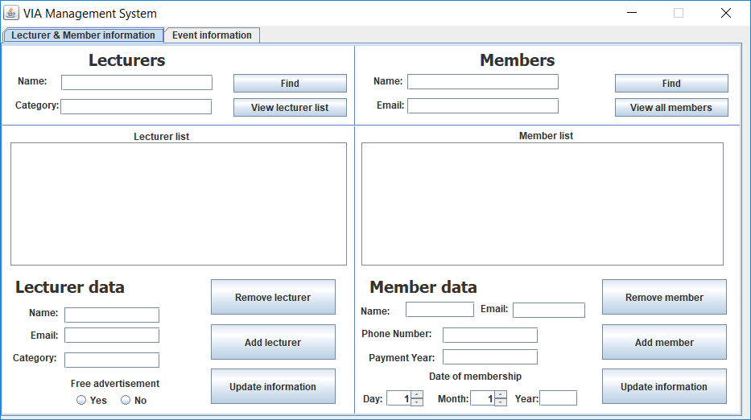

**Description:**

This is the start screen for the program. The main tab of the program is entitled “**Lecturer & Member information**” and contains four sections: “**Member data**”, “**Members**”, “**Lecturer** **data**”, and “**Lecturers**”.

1. **Lecturer & Member information:**
2. 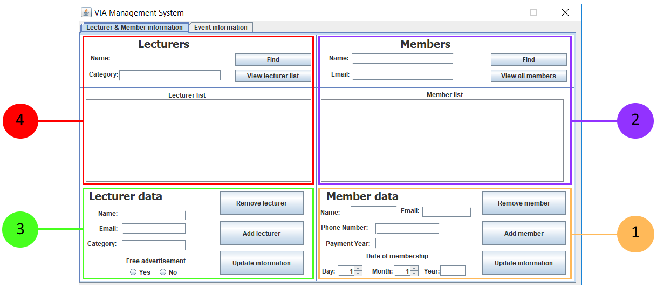 **Member data:**

Within the member section, you are able to add new members, modify existing information and remove a member.

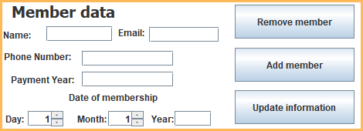

**To add a member:**

1. Fill the name field with the member’s information;
2. Fill the email field with the member’s information;
3. Fill the phone number field with the information provided by the customer;
4. Write the payment year in the payment year field;
5. Select the date of membership for the member which includes day, month and year;
6. Press the “Add member” button to store the member’s information.

Upon successful input of information, you will be presented with the following message:

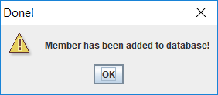

Information about the member has now been stored and you may close this window.

1.  **Members:**

To find, remove or update an existing member, you will need to have added that member first before being able to modify member information. You are able to find a member by either name or email.

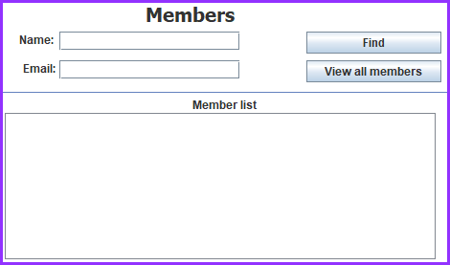

**To find a member:**

1. Enter relevant search information about the member in the name field (Optional if step b has been done);
2. Enter email address of member in the email field (Optional if step a has been done);
3. Click on the “Find” button;

Upon successful search, you will be presented with the desired member in the member list:

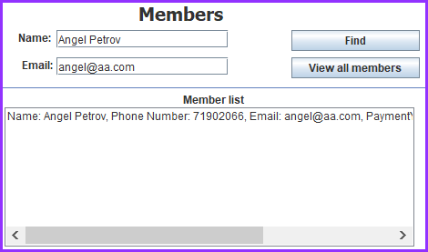

**Viewing all members:**

1. Click on the “View all members” button;
2. The program will show all available members that have been added to the program, prior to viewing all members:

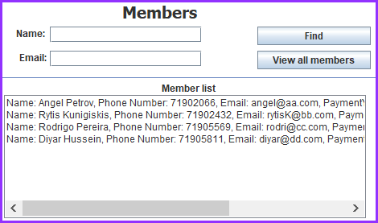

**Removing a member from the member list:**

1. Select a member that you wish to remove from the member list;
2. In the “Members data” section, click on the “Remove member” button:

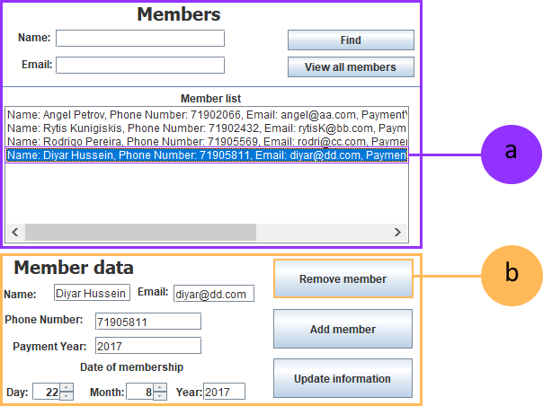

Upon successful deletion of a member, you will be presented with the following message:

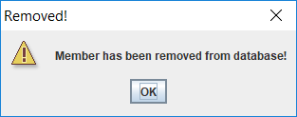

Information about the member has now been updated and you may close this window.

**Updating information about member:**

1. Select a member that you wish to update information about from the member list and edit any desired information about the member;
2. Click on the “Update information” button to save updated information.

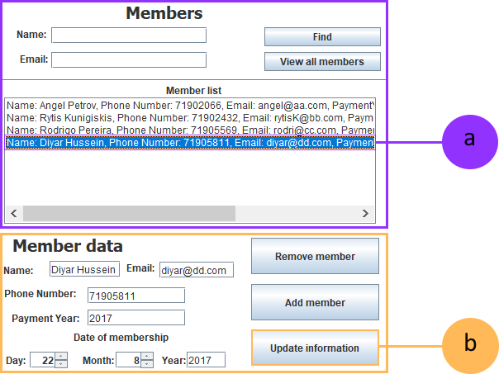

Upon successful update of a member information, you will be presented with the following message:

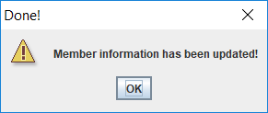

Information about the member has now been updated and you may close this window.

1.  **Lecturer data:**

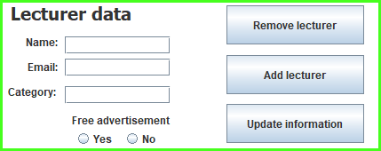Within the lecturers section, you are able to add new lecturers, modify existing information and remove a lecturer.

**To add a lecturer:**

1. Fill the name field with the lecturer’s information;
2. Fill the email field with the lecturer’s information;
3. Write the category that the lecturer will be in;
4. Write the payment year in the payment year field;
5. Select the date of membership for the member which includes day, month and year;
6. Press the “Add member” button to store the member’s information.

Upon successful input of information, you will be presented with the following message:



Information about the member has now been stored and you may close this window.

1.  **Lecturers:**

To find, remove or update an existing lecturer, you will need to have added that lecturer first before being able to modify lecturer information. You are able to find a lecturer by either name or category.

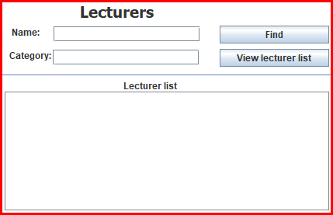

**To find a lecturer:**

1. Enter relevant search information about the lecturer in the name field (Optional if step b has been done);
2. Enter email address of member in the email field (Optional if step a has been done);
3. Click on the “Find” button;

Upon successful search, you will be presented with the desired lecturer in the lecturer list:

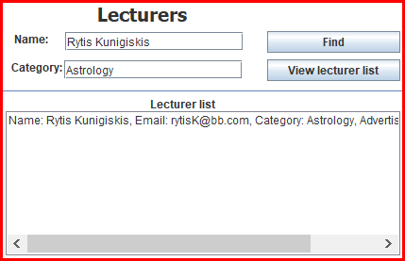

**Viewing all lecturers:**

1. Click on the “View lecturer list” button;
2. The program will show all available lecturers that have been added to the program, prior to viewing all lectures:

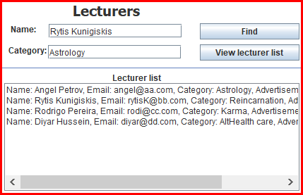

**Removing a lecturer from the member list:**

1. Select a lecturer that you wish to remove from the lecture list;
2. In the “Lecturer data” section, click on the “Remove lecturer” button:

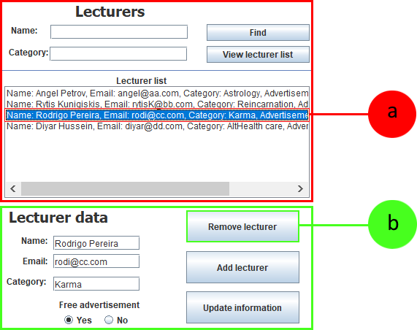

**Updating information about lecturer:**

1. Select a lecturer that you wish to update information about from the lecturer list and edit any desired information about the lecturer;
2. Click on the “Update information” button to save updated information.

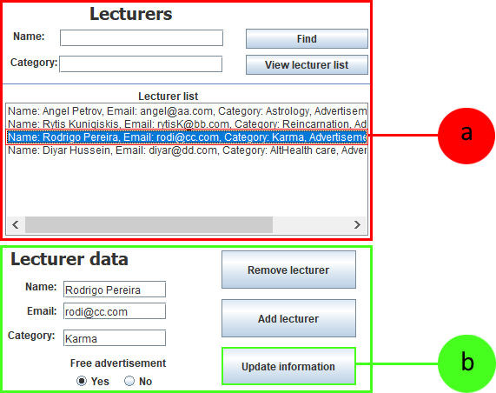

Upon successful update of a member information, you will be presented with the following message:

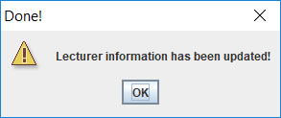

Information about the lecturer has now been updated and you may close this window.

1. **Event Information:**

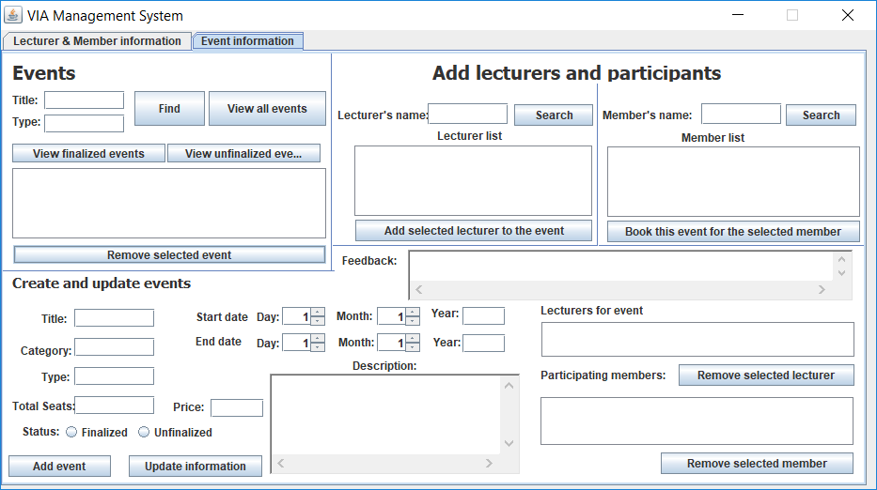

**Description:**

The illustration above is and overview of the event tab which contains three sections: “**Create and update events**”, “**Events**” and “**Add lecturers and participants**”.

1. 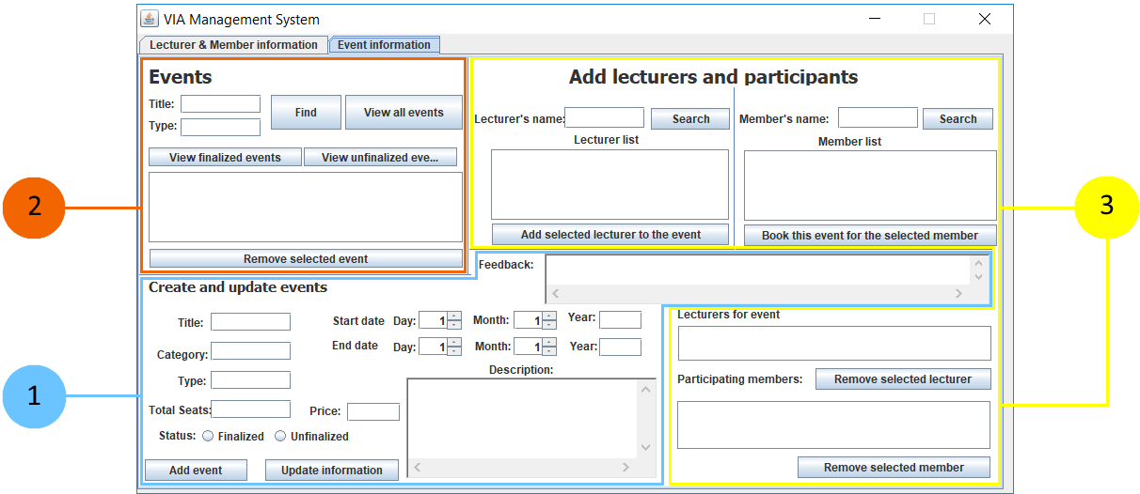 **Sections of Event information:**
2.  **Create and update events:**

In the create and update events section, you are able add information for an event, its starting and ending time, a description for the event and leave feedback.

**Creating an event:**

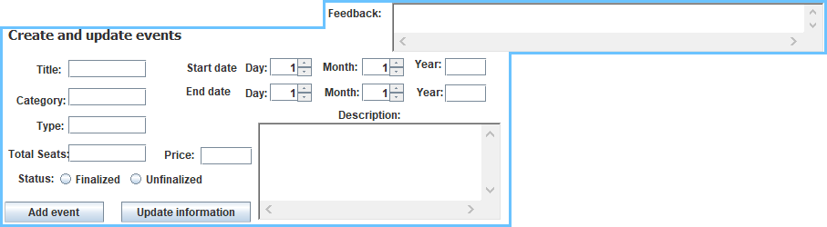

1. Fill the tittle field with the title of the event;
2. Write in which category the event is within the category field;
3. Specify the type of event in the type field;
4. Fill the total seats for the event in the total seats field;
5. Specify the price for the event in the price field;
6. Choose one of the available buttons - “Finalized” or “Unfocalized” depending on event status;
7. Select the start day, month and fill in the year field with the event start date;
8. Select the end day, month and fill in the year field with the event end date;
9. Optionally, give a description for the given event in the “Description” field;
10. Optionally, leave feedback for the given event in the “Feedback” field;
11. Press the “Add event” button to save event information;

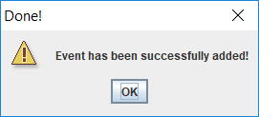Upon successful input of information, you will be presented with the following message:

Information about the lecturer has now been updated and you may close this window.

1. **Events:**

In the events section, you are able to find events by either title, type or both.

**Finding an event:**

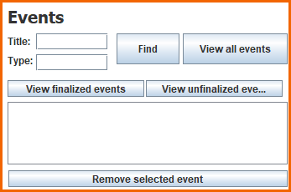

1. Enter the title of the event that you would like to find in the title field (Optional if step b has been done);
2. Enter the type of the event that you would like to find in the type field (Optional if step a has been done);
3. Click on the “Find” button to find events based on the search preferences that you provided.

Upon successful search, you will be presented with the desired lecturer in the lecturer list:

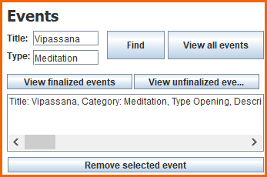

1. To get a list of all events that have been added, click on the button “View all events”;
2. To get a list of events that have been finalized, click on the button “View finalized events”;
3. To get a list of events that have not been finalized yet, click on the button “View unfinalized events”.

**Editing event information:**

1. Select an event that you wish to update information about from the events section;
2. Click on the “Update information” button to save updated information.

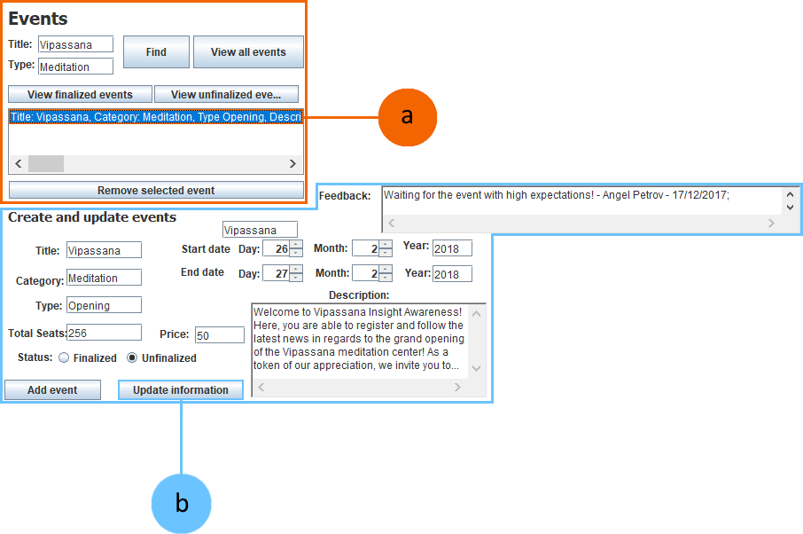

Upon successful input of information, you will be presented with the following message:

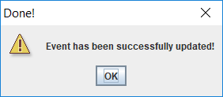

Information about the lecturer has now been updated and you may close this window.

1. **Add lecturers and participants:**

The lecturers and participants section provides the possibility to add lectures and participants for a selected event that have already been added under the “Lecturer & Member information” in the sections “Lecturer data” and “Member data”.

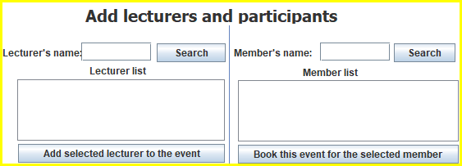

**Searching for lecturers:**

1. Fill in the lecturer’s name in the designated field;
2. Press the “Search” button to search with the given criteria;

**Searching for members:**

1. Fill in the member’s name in the designated field;
2. Press the “Search” button to search with the given criteria;

**Assigning a lecturer to an event:**

1. From the lecturer list, select a desired lecturer;
2. Click on the “Add selected lecturer to the event” button;



**Note:** Lecturer will now be added in the “Lecturers for event” list;

1. Click on the “Update information” button in the “Create and update events” section;

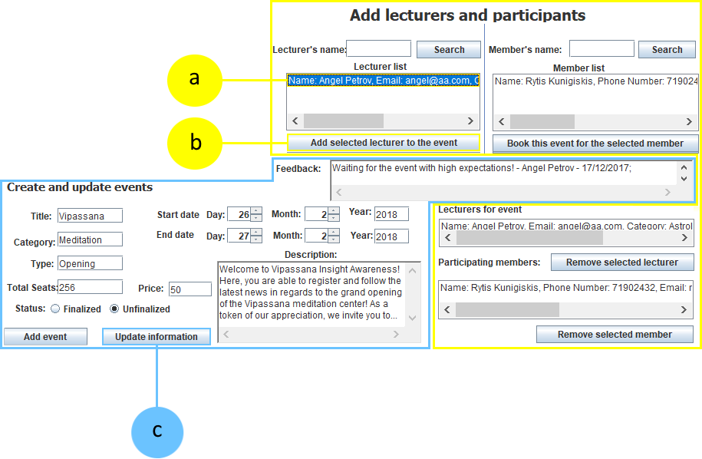

Upon successful input of information, you will be presented with the following message:



Information about the lecturer has now been updated and you may close this window.

**Assigning a member to an event:**

1. From the member list, select a desired member;
2. Click on the “Book this event for the selected member” button;



**Note:** Member will now be added in the “Lecturers for event” list;

1. Click on the “Update information” button in the “Create and update events” section;

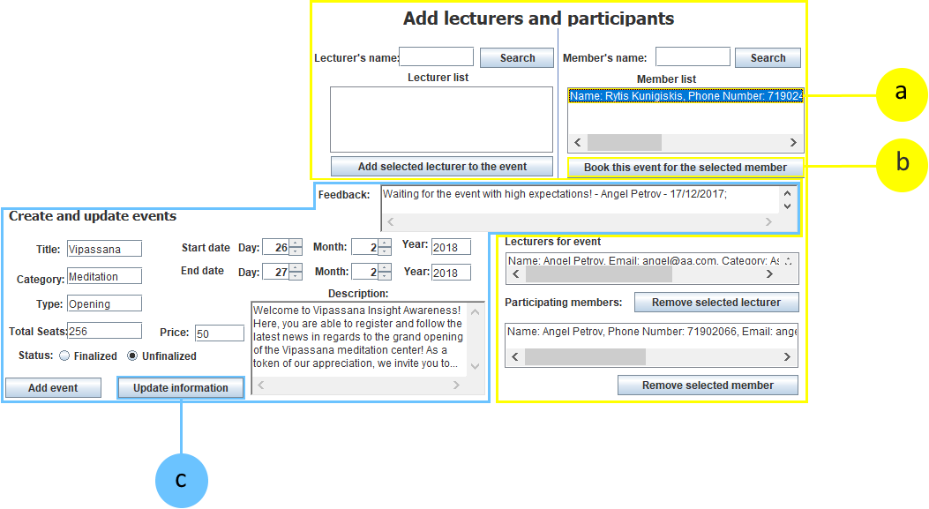

Upon successful input of information, you will be presented with the following message:



Information about the event has now been updated and you may close this window.

**Removing a lecturer from an event:**

1. From the “Lecturers for event”, select the desired lecturer that you would like to remove for the currently selected event;
2. Click on the “Remove selected lecturer”;
3. Click on the “Update information” button in the “Create and update events” section;

Upon successful input of information, you will be presented with the following message:



Information about the event has now been updated and you may close this window.

**Removing a member from an event:**

1. From the “Lecturers for event”, select the desired lecturer that you would like to remove for the currently selected event;
2. Click on the “Remove selected lecturer”;
3. Click on the “Update information” button in the “Create and update events” section;

Upon successful input of information, you will be presented with the following message:



Information about the event has now been updated and you may close this window.

Thank you for consulting with this manual! We hope that you enjoy using this software!

Version 1.06 – 18 / 12 / 2017